New player in Forklift clamps

  - Hagabergs Mekaniska AB is expanding its range in the Nordic market and now also offers a complete range of clamp attachments, rotators and more for industrial trucks and wheel loaders. The company becomes the exclusive distributor of products from the Spanish manufacturer Cebriá.

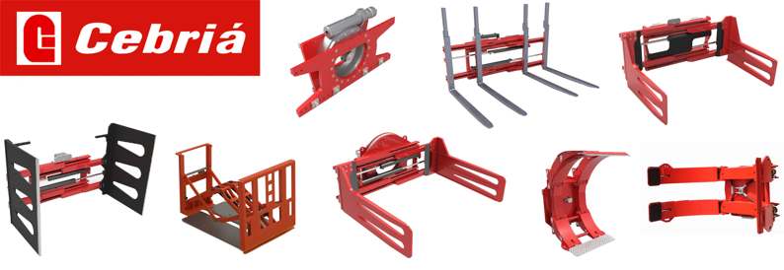

Hagabergs Mekaniska has signed an exclusivity agreement regarding the distribution of the Spanish manufacturer Cebriá's products for the Nordic market. The range consists of clamp attachments for paper rolls, pulp bales, appliances, cartons and rotators, multi-fork positioners, telescopic positioners, etcetera. With this expansion, Hagbergs will become a full-range supplier for industrial trucks and wheel loaders to the paper and pulp industry, appliance warehouses, recycling centers, breweries, foundries and more.

Cebriá is a Spanish family business founded in 1973, which essentially has a wide standard range and additionally designs and manufactures customized solutions.

Hagabergs and Cebriá have many common denominators as companies and in terms of the level of quality the products maintain. We are very much looking forward to offering our existing and new customers a wider range and effective solutions for the individual users, says Stefan Carlsson Pautt, CBDO.

Shortly, our website will be updated with the complete expanded range, though the products are available to order already, Stefan concludes.

  - Files and images
https://www.hagaberg.com/en/media-library/

  - We are happy to provide more information
Stefan Carlsson Pautt  CBDO  Phone: +46 70 710 74 04  E-mail: stefan@hagaberggroup.com | Sara Martinsson  Marketing assistant  Phone: +46 706 06 57 77  E-mail: sara@hagaberggroup.com

